DFS Implementation in Python (Source Code)
Now, knowing the algorithm to apply the Depth-First Search implementation in python, we will see how the source code of the program works.
Consider the following graph which is implemented in the code below:
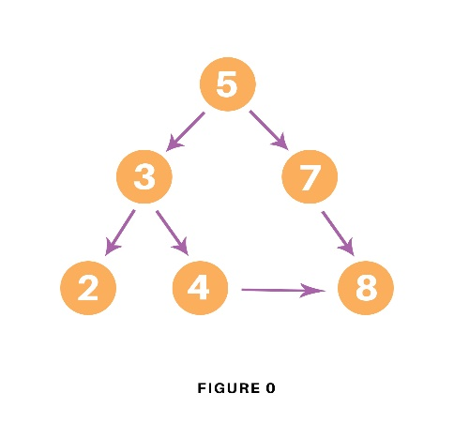
# Using a Python dictionary to act as an adjacency list
graph = {
'5' : ['3','7'],
'3' : ['2', '4'],
'7' : ['8'],
'2' : [],
'4' : ['8'],
'8' : []
}

visited = set() # Set to keep track of visited nodes of graph.
def dfs(visited, graph, node): #function for dfs
if node not in visited:
print (node)
visited.add(node)
for neighbour in graph[node]:
dfs(visited, graph, neighbour)
# Driver Codeprint("Following is the Depth-First Search")
dfs(visited, graph, '5')

Output
The output of the above code is as follow:
Following is the Depth-First Search
5 3 2 4 8 7

BFS algorithm
A standard BFS implementation puts each vertex of the graph into one of two categories:
- Visited
- Not Visited
The purpose of the algorithm is to mark each vertex as visited while avoiding cycles.
The algorithm works as follows:
- Start by putting any one of the graph's vertices at the back of a queue.
- Take the front item of the queue and add it to the visited list.
- Create a list of that vertex's adjacent nodes. Add the ones which aren't in the visited list to the back of the queue.
- Keep repeating steps 2 and 3 until the queue is empty.
The graph might have two different disconnected parts so to make sure that we cover every vertex, we can also run the BFS algorithm on every node

BFS example
Let's see how the Breadth First Search algorithm works with an example. We use an undirected graph with 5 vertices.
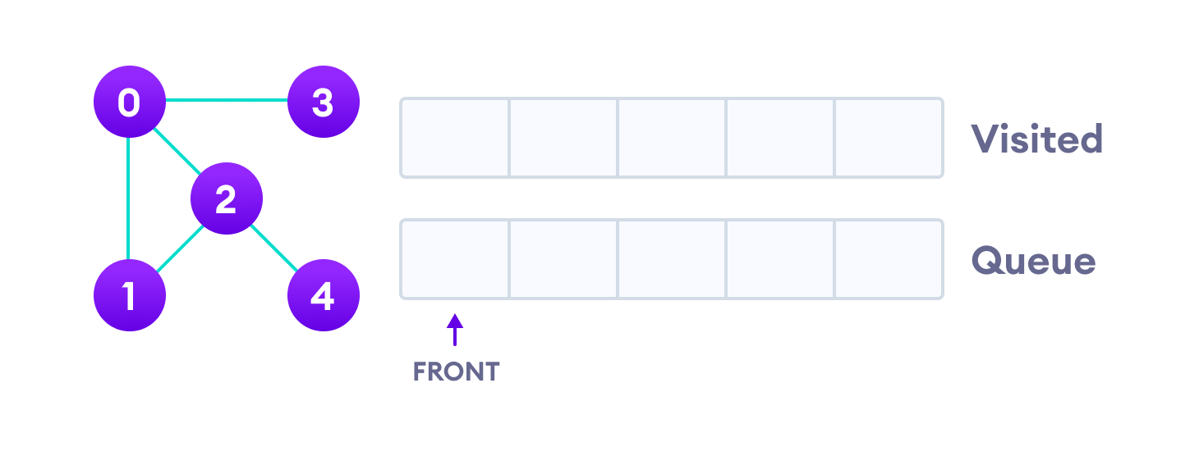Undirected graph with 5 vertices
We start from vertex 0, the BFS algorithm starts by putting it in the Visited list and putting all its adjacent vertices in the stack.
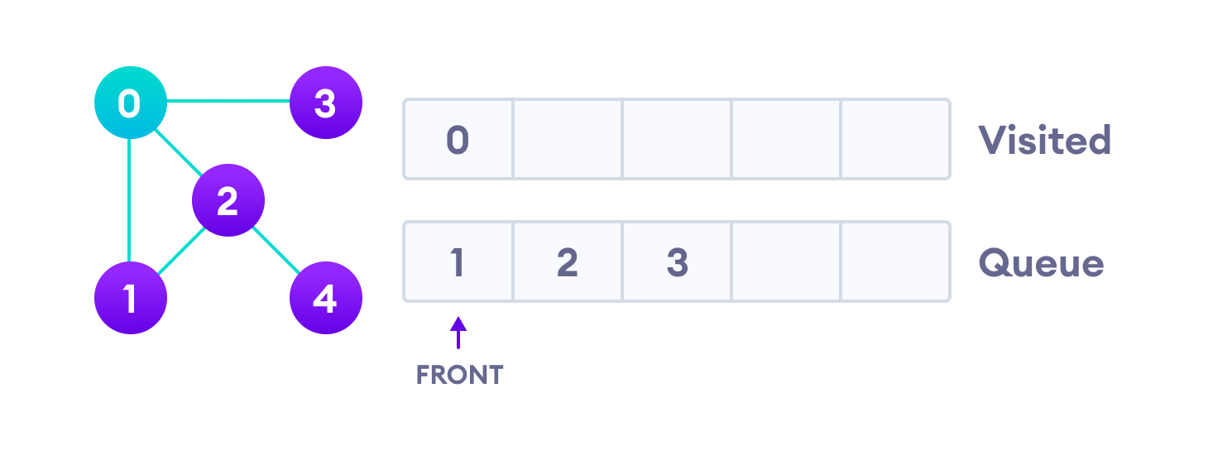Visit start vertex and add its adjacent vertices to queue
Next, we visit the element at the front of queue i.e. 1 and go to its adjacent nodes. Since 0 has already been visited, we visit 2 instead.
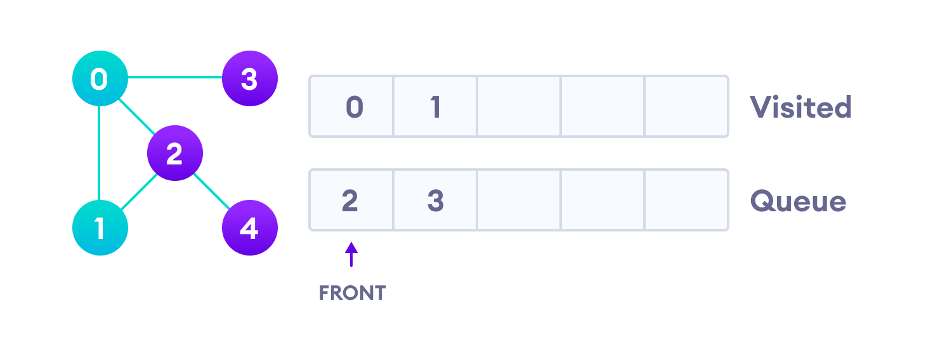Visit the first neighbour of start node 0, which is 1
Vertex 2 has an unvisited adjacent vertex in 4, so we add that to the back of the queue and visit 3, which is at the front of the queue.
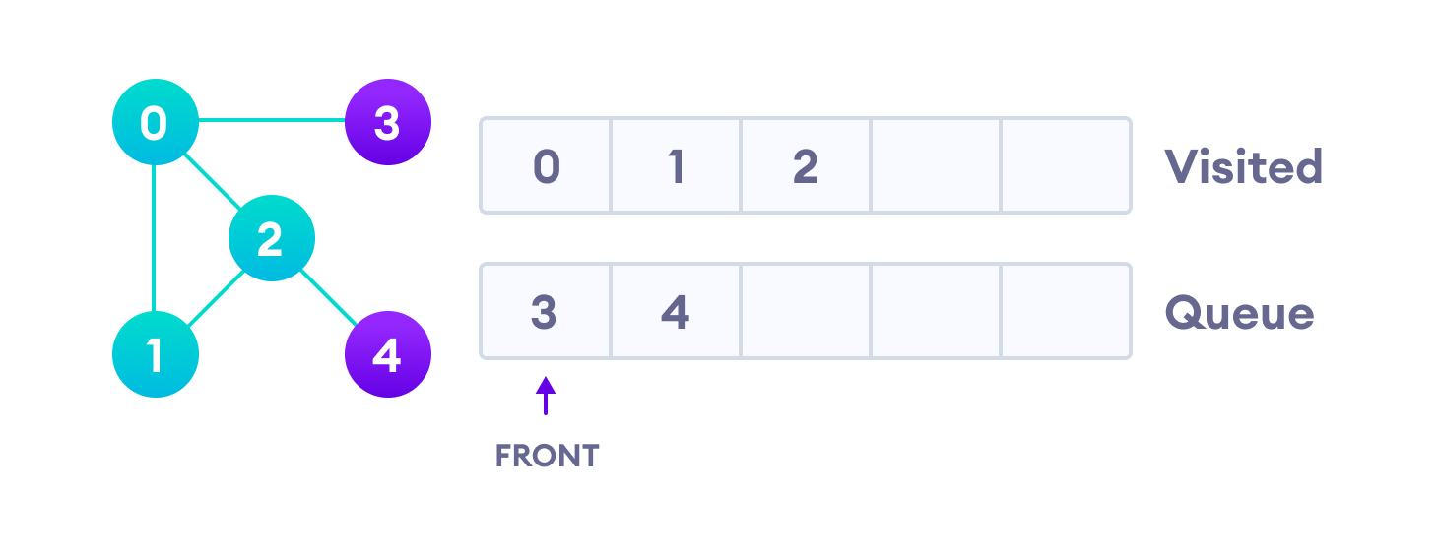Visit 2 which was added to queue earlier to add its neighbour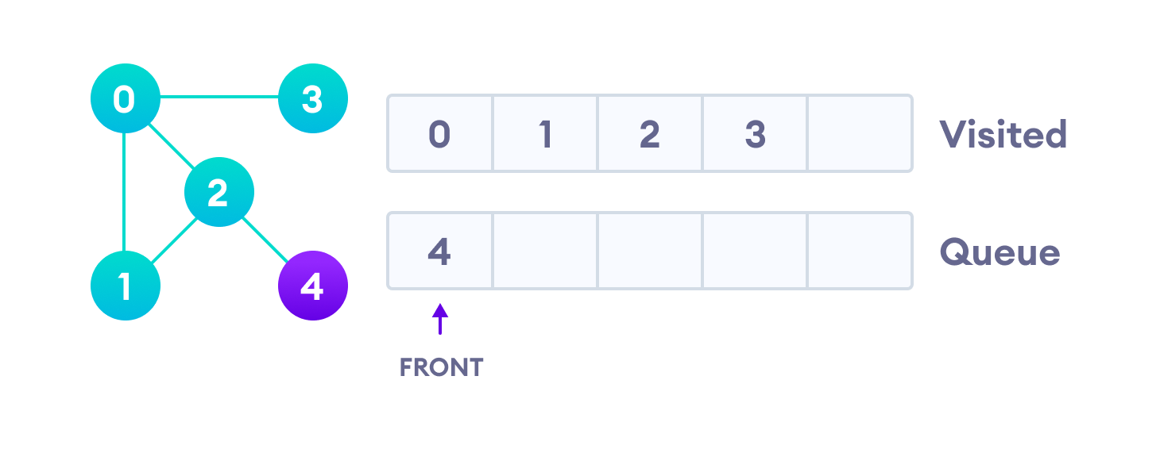4 remains in the queue
Only 4 remains in the queue since the only adjacent node of 3 i.e. 0 is already visited. We visit it.

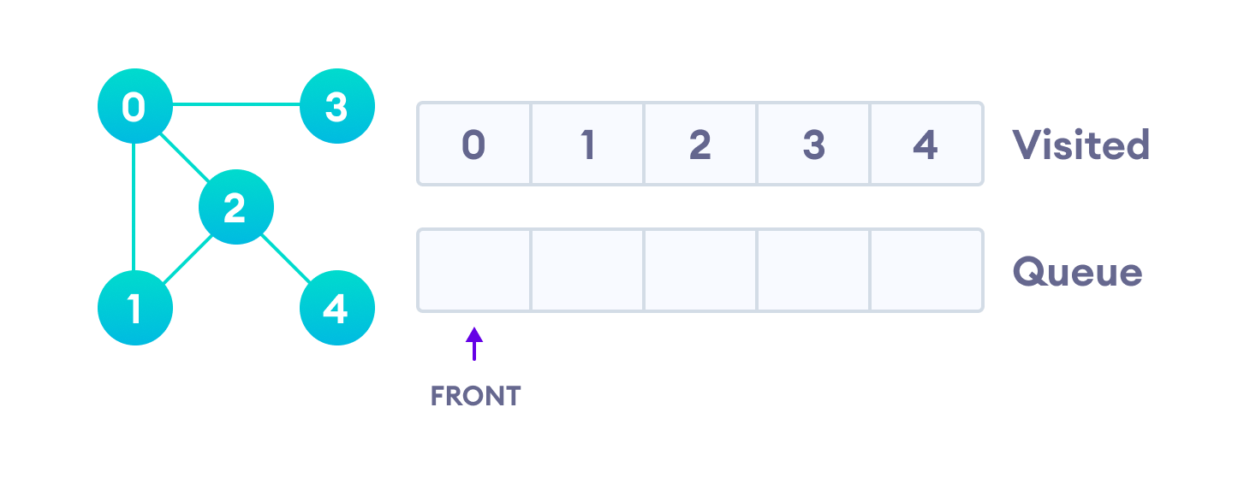Visit last remaining item in the queue to check if it has unvisited neighbors
Since the queue is empty, we have completed the Breadth First Traversal of the graph.

# BFS algorithm in Python

import collections
# BFS algorithmdef bfs(graph, root):

visited, queue = set(), collections.deque([root])
visited.add(root)

while queue:

# Dequeue a vertex from queue
vertex = queue.popleft()
print(str(vertex) + " ", end="")

# If not visited, mark it as visited, and
# enqueue it
for neighbour in graph[vertex]:
if neighbour not in visited:
visited.add(neighbour)
queue.append(neighbour)

if __name__ == '__main__':
graph = {0: [1, 2], 1: [2], 2: [3], 3: [1, 2]}
print("Following is Breadth First Traversal: ")
bfs(graph, 0)

Bidirectional Search
Consider following simple example-
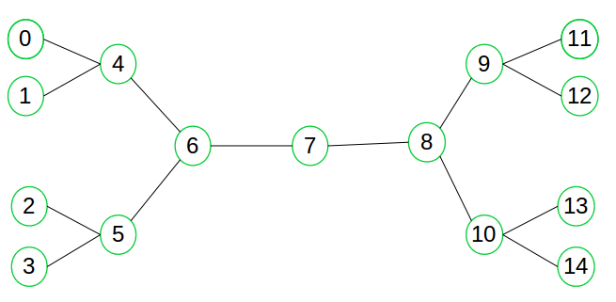
# Python3 program for Bidirectional BFS
# Search to check path between two vertices

# Class definition for node to
# be added to graph
class AdjacentNode:

def __init__(self, vertex):

self.vertex = vertex
self.next = None

# BidirectionalSearch implementation
class BidirectionalSearch:

def __init__(self, vertices):

# Initialize vertices and
# graph with vertices
self.vertices = vertices
self.graph = [None] * self.vertices

# Initializing queue for forward
# and backward search
self.src_queue = list()
self.dest_queue = list()

# Initializing source and
# destination visited nodes as False
self.src_visited = [False] * self.vertices
self.dest_visited = [False] * self.vertices

# Initializing source and destination
# parent nodes
self.src_parent = [None] * self.vertices
self.dest_parent = [None] * self.vertices

# Function for adding undirected edge
def add_edge(self, src, dest):

# Add edges to graph

# Add source to destination
node = Adjacent Node(dest)
node.next = self.graph[src]
self.graph[src] = node

# Since graph is undirected add
# destination to source
node = AdjacentNode(src)
node.next = self.graph[dest]
self.graph[dest] = node

# Function for Breadth First Search
def bfs(self, direction = 'forward'):

if direction == 'forward':

# BFS in forward direction
current = self.src_queue.pop(0)
connected_node = self.graph[current]

while connected_node:
vertex = connected_node.vertex

if not self.src_visited[vertex]:
self.src_queue.append(vertex)
self.src_visited[vertex] = True
self.src_parent[vertex] = current

connected_node = connected_node.next
else:

# BFS in backward direction
current = self.dest_queue.pop(0)
connected_node = self.graph[current]

while connected_node:
vertex = connected_node.vertex

if not self.dest_visited[vertex]:
self.dest_queue.append(vertex)
self.dest_visited[vertex] = True
self.dest_parent[vertex] = current

connected_node = connected_node.next

# Check for intersecting vertex
def is_intersecting(self):

# Returns intersecting node
# if present else -1
for i in range(self.vertices):
if (self.src_visited[i] and
self.dest_visited[i]):
return i

return -1

# Print the path from source to target
def print_path(self, intersecting_node,
src, dest):

# Print final path from
# source to destination
path = list()
path.append(intersecting_node)
i = intersecting_node

while i != src:
path.append(self.src_parent[i])
i = self.src_parent[i]

path = path[::-1]
i = intersecting_node

while i != dest:
path.append(self.dest_parent[i])
i = self.dest_parent[i]

print("*****Path*****")
path = list(map(str, path))

print(' '.join(path))

# Function for bidirectional searching
def bidirectional_search(self, src, dest):

# Add source to queue and mark
# visited as True and add its
# parent as -1
self.src_queue.append(src)
self.src_visited[src] = True
self.src_parent[src] = -1

# Add destination to queue and
# mark visited as True and add
# its parent as -1
self.dest_queue.append(dest)
self.dest_visited[dest] = True
self.dest_parent[dest] = -1

while self.src_queue and self.dest_queue:

# BFS in forward direction from
# Source Vertex
self.bfs(direction = 'forward')

# BFS in reverse direction
# from Destination Vertex
self.bfs(direction = 'backward')

# Check for intersecting vertex
intersecting_node = self.is_intersecting()

# If intersecting vertex exists
# then path from source to
# destination exists
if intersecting_node != -1:
print(f"Path exists between {src} and {dest}")
print(f"Intersection at : {intersecting_node}")
self.print_path(intersecting_node
src, dest)
exit(0)
return -1

# Driver code
if __name__ == '__main__':

# Number of Vertices in graph
n = 15

# Source Vertex
src = 0

# Destination Vertex
dest = 14

# Create a graph
graph = BidirectionalSearch(n)
graph.add_edge(0, 4)
graph.add_edge(1, 4)
graph.add_edge(2, 5)
graph.add_edge(3, 5)
graph.add_edge(4, 6)
graph.add_edge(5, 6)
graph.add_edge(6, 7)
graph.add_edge(7, 8)
graph.add_edge(8, 9)
graph.add_edge(8, 10)
graph.add_edge(9, 11)
graph.add_edge(9, 12)
graph.add_edge(10, 13)
graph.add_edge(10, 14)

out = graph.bidirectional_search(src, dest)

if out == -1:
print(f"Path does not exist between {src} and {dest}")

Output:
Path exist between 0 and 14
Intersection at: 7
*****Path*****
0 4 6 7 8 10 14

Uniform-Cost Search (Dijkstra for large Graphs)

Examples:
Input :
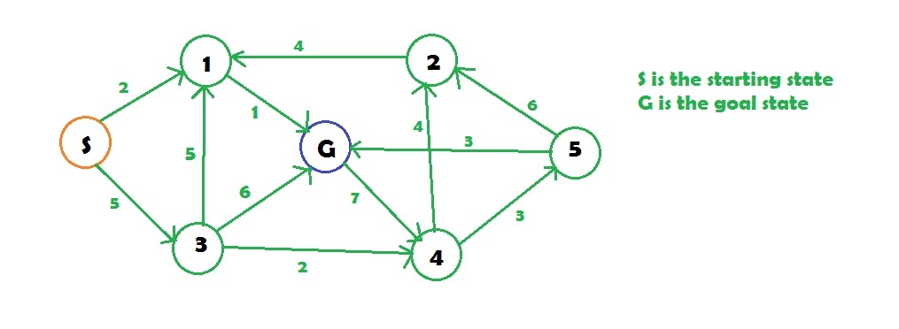
S is the starting state
G is the goal state

# Python3 implementation of above approach

# returns the minimum cost in a vector( if
# there are multiple goal states)
def uniform_cost_search(goal, start):

# minimum cost upto
# goal state from starting
global graph,cost
answer = []

# create a priority queue
queue = []

# set the answer vector to max value
for i in range(len(goal)):
answer.append(10**8)

# insert the starting index
queue.append([0, start])

# map to store visited node
visited = {}

# count
count = 0

# while the queue is not empty
while (len(queue) > 0):

# get the top element of the
queue = sorted(queue)
p = queue[-1]

# pop the element
del queue[-1]

# get the original value
p[0] *= -1

# check if the element is part of
# the goal list
if (p[1] in goal):

# get the position
index = goal.index(p[1])

# if a new goal is reached
if (answer[index] == 10**8):
count += 1

# if the cost is less
if (answer[index] > p[0]):
answer[index] = p[0]

# pop the element
del queue[-1]

queue = sorted(queue)
if (count == len(goal)):
return answer

# check for the non visited nodes
# which are adjacent to present node
if (p[1] not in visited):
for i in range(len(graph[p[1]])):

# value is multiplied by -1 so that
# least priority is at the top
queue.append( [(p[0] + cost[(p[1], graph[p[1]][i])])* -1, graph[p[1]][i]])

# mark as visited
visited[p[1]] = 1

return answer

# main function
if __name__ == '__main__':

# create the graph
graph,cost = [[] for i in range(8)],{}

# add edge
graph[0].append(1)
graph[0].append(3)
graph[3].append(1)
graph[3].append(6)
graph[3].append(4)
graph[1].append(6)
graph[4].append(2)
graph[4].append(5)
graph[2].append(1)
graph[5].append(2)
graph[5].append(6)
graph[6].append(4)

# add the cost
cost[(0, 1)] = 2
cost[(0, 3)] = 5
cost[(1, 6)] = 1
cost[(3, 1)] = 5
cost[(3, 6)] = 6
cost[(3, 4)] = 2
cost[(2, 1)] = 4
cost[(4, 2)] = 4
cost[(4, 5)] = 3
cost[(5, 2)] = 6
cost[(5, 6)] = 3
cost[(6, 4)] = 7

# goal state
goal = []

# set the goal
# there can be multiple goal states
goal.append(6)

# get the answer
answer = uniform_cost_search(goal, 0)

# print the answer
print("Minimum cost from 0 to 6 is = ",answer[0])

